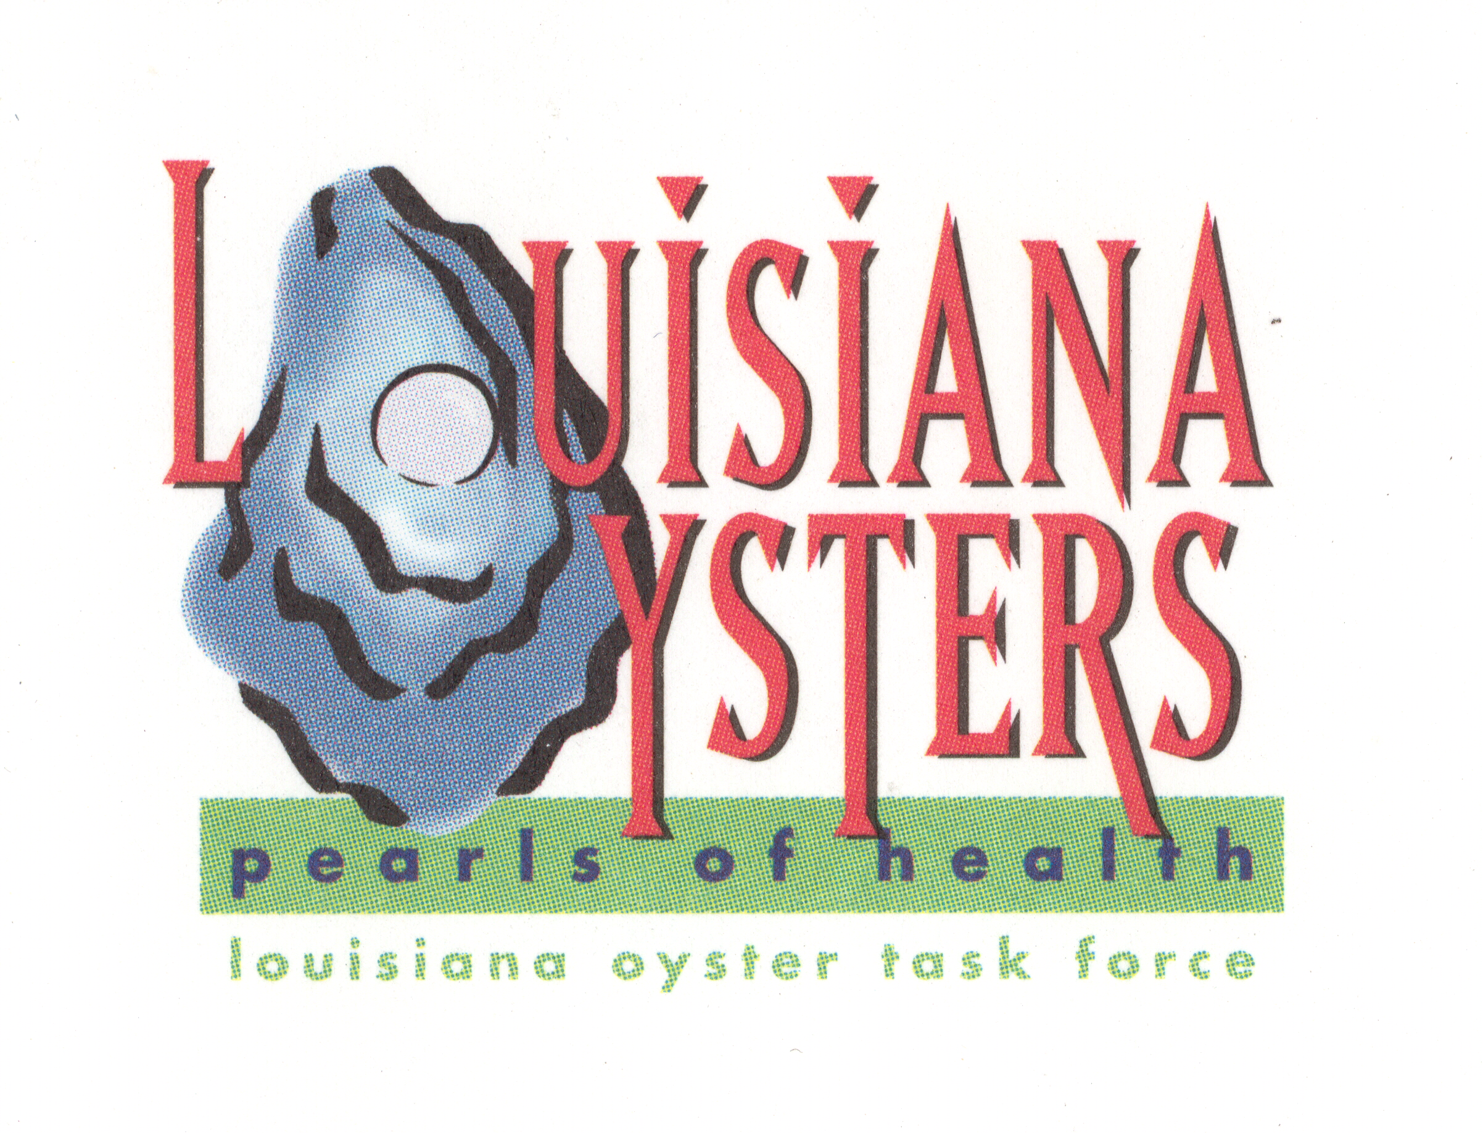
Louisiana Oyster Task Force Legislative Committee Meeting
Legislative Committee Chair, Ralph “Buddy” Pausina
Tuesday, March 29, 10 a.m. UNO Advanced Technology Center
2021 Lakeshore Drive, Suite 210

AGENDA

I. Amending the intrastate 5 hours from harvest to refrigeration allowance for raw sales and consumption within the State of Louisiana.
II. Legal standard for measuring sack oysters/ providing legal sized baskets for harvesters and dealers.

Louisiana Oyster Task Force Meeting
John Tesvich, Chairman

Tuesday March 29, 2011 1:00 PM
UNO Advanced Technology Center, 2021 Lakeshore Drive, Suite 210

AGENDA

- Roll Call
- Approval of January 25, 2011 MINUTES
- Treasury Report
A. Oyster Tag Sales
B. LOTF Financial Report
IV. Committee Reports
A. Public and Private Oyster Grounds Committee – (Buddy Pausina)
B. Enforcement - (Keith Lacaze)
C. Legislative - (Jakov Jurisic)
D. Research – (John Supan)
E. Coastal Restoration – (Dan Coulon)
F. Marketing - (Dana Brocato)
G. Health – (Glenn Cambre)
V. Old Business
    - Public Oyster Reef Evaluation & Shell Plant – Patrick Banks
    - BP Oil Spill Remediation
      - Claims Process
      - Public Reef Remediation
      - Oyster Lease Remediation
    - Report on Washington Walk-on-the-Hill and functions
    - Oyster Lease Moratorium Update, Map of Dual Claim Water-bottoms – Jerome Zeringue, Raymond Impastato
VI. New Business
- Anne Dale-LaPearlite
- Crop Insurance Update – Rob Certa
- Sabine Lake Oyster Harvest Recommendations – Mike Voisin
- NFI Spring Conference, May 10-12,2011 – Mike Voisin
- Army Corp of Engineers Shellfish Permit Reauthorization
- Acknowledgements: Keith Lacaze, Tommy Cvitanovich

- Set Next Meeting
- Adjourn

